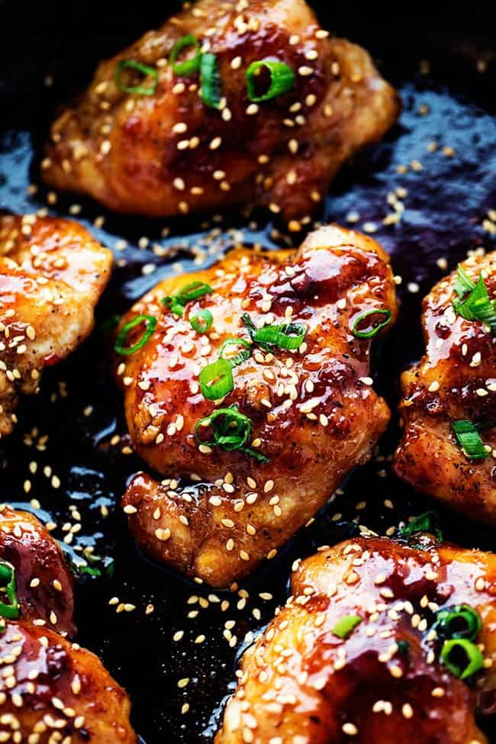
Asian Glazed Chicken
Prep time 5 min Cook time 15 min
4 Servings
Ingredients
1 lb thinly sliced chicken breasts
1 tbsp olive oil
¾ cup brown sugar
⅓ cup soy sauce
2 tbsp hoisin sauce
1 tbsp Sweet Chili Sauce
1 tbsp ginger peeled and grated
Pinch of dried red pepper flakes
½ teaspoon minced garlic
1/8 cup lime juice
Directions
- In a large skillet, heat oil over medium heat. Season the chicken with salt and pepper. Brown the chicken on both sides. Remove chicken from skillet and set aside.
- In the skillet whisk together brown sugar, soy sauce, hoisin sauce, sweet chili sauce, ginger, red pepper flakes, garlic and lime juice. Bring to a boil over medium heat for 1-2 minutes until sauce thickens.
- Add chicken back to the sauce and coat each side with the sauce. Garnish with sesame seeds and chopped green onions.

